**Problem Description:**

RRTechnicals, a study center allows students to register for two types of certification courses - CrashCourseCertification and RegularCourseCertification. For this, the center has to comply with the standards set for all certifications.

Also, an admission test is conducted for all the students who want to apply, and the marks scored in the admission test is considered for a discount on their total fees as per the table below:

| **Marks** | **Discount %** |
| --- | --- |
| 90 or greater | 10 |
| 75 to 89 (Both inclusive) | 5 |

An extra 12.36% service tax is applicable on discounted fee for crash course. Since regular course students are paying more amount, they are exempted from the service tax.

Create the required interface and classes as per class diagrams given below:

**Certification:**

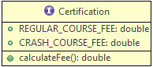

The **Certification**interface provides the standards for all certifications. It specifies the standard fees for the courses and a method to calculate the final fee for the study centers. The regular courses can be of 5-6 months duration for which the fee is Rs. 2000 per month. The crash course duration is fixed to 2 months and the fee is Rs. 5000.

**RRTechnicalCertification:** The parent class which complies with the certification interface and provides the common features for different types of RRTechnical certifications.

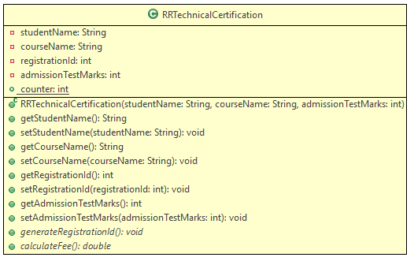

**RegularCourseCertification:**

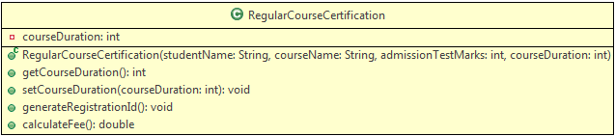

**CrashCourseCertification:**

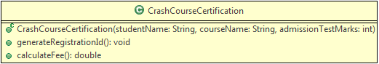

**Method Description:**

**generateRegistrationId():** This method is used to generate a unique registration id for the certification of each student. The id for regular courses must contain a 4 digit odd number, starting with 1001. For crash course, the id must contain a 4 digit even number.  
**Note:** The registration id should get generated as soon as a student is registered (i.e. when an object is created) and it need not follow any sequence.

**calculateFee()**: This method is used to calculate the total certification fees for the students of RRTechnicals. Make appropriate use of the interface and the above mentioned business conditions to determine the total fee amount.

Use the Tester class to check your code and display the results as shown in the sample output.

**Sample:**

**Input (for RegularCourseCertification):**

| **Attribute** | **Value** |
| --- | --- |
| Student Name | Rakesh |
| Course Name | J2EE |
| Course Duration | 5 |
| Admission Test Marks | 85 |

Output:

1. Regular Course Registration Details
2. ***********************************
3. Student Name : Rakesh
4. Course Name : J2EE
5. Course Duration : 5 months
6. Registration ID : 1001
7. Fees : 9500.0

Input (for CrashCourseCertification):

| **Attribute** | **Value** |
| --- | --- |
| Student Name | Roshan |
| Course Name | Angular |
| Admission Test Marks | 71 |

Output:

1. Crash Course Registration Details
2. *********************************
3. Student Name : Roshan
4. Course Name : Angular
5. Course Duration : 2 months
6. Registration ID : 1002
7. Fees : 5618.0

Create a new Java Project and implement the given requirements.

**Note**: Check the project using SonarLint to maintain the coding standards. Ignore the violations which occur due to "System.out" statements.